Lab Submission: 3

Student Name: Michael Daly

Course and Section: CST8215 – 362

========================================================================

Lab 3 – Creating, populate and analyze database objects and content

In this Lab, we will use the script – Practice-DDL-DML script. Please ensure you have downloaded it to your laptop prior to beginning. This is a short lab to review the running of sql scripts and simple data analysis.

Grading: Lab 3 is worth 3 marks

========================================================================

**Create the table called ‘Practice’ and add data to this table**

Using the PGAdmin Query Tool, copy and paste the content of Practice-DDL-DML into the query window and execute (lightning bolt).

Look at the sample message section of the screen at the bottom to ensure the script ran without errors

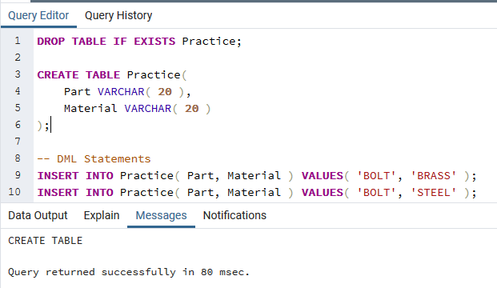

**SQL statement practice (3 marks - .5 each)**

How many rows in the PRACTICE table have a *part e*qual to ‘BOLT’

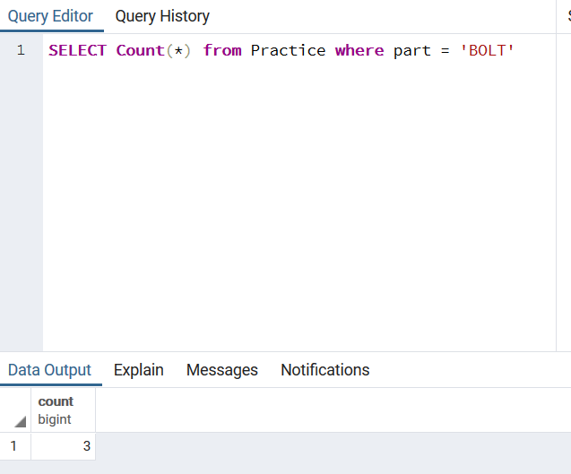

List all SCREWS from the table PRACTICE

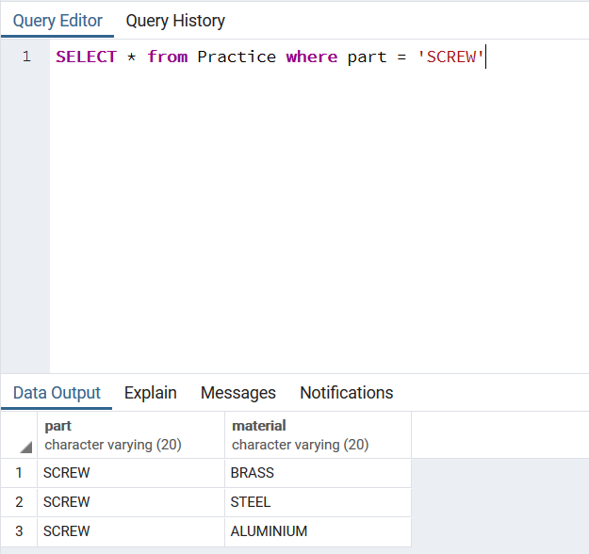

List all rows where the *part* is made of ‘BRASS’

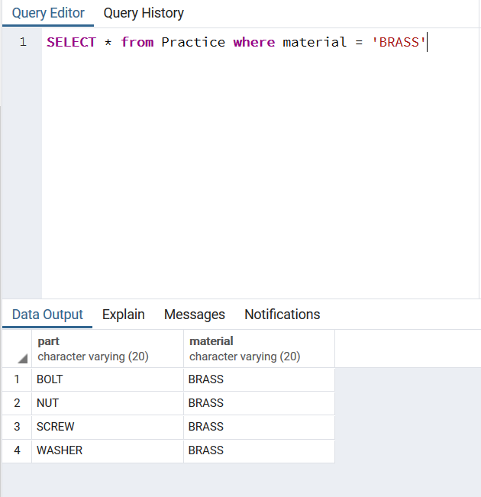

List all rows where the *part* is either a ‘SCREW’ or ‘WASHER’

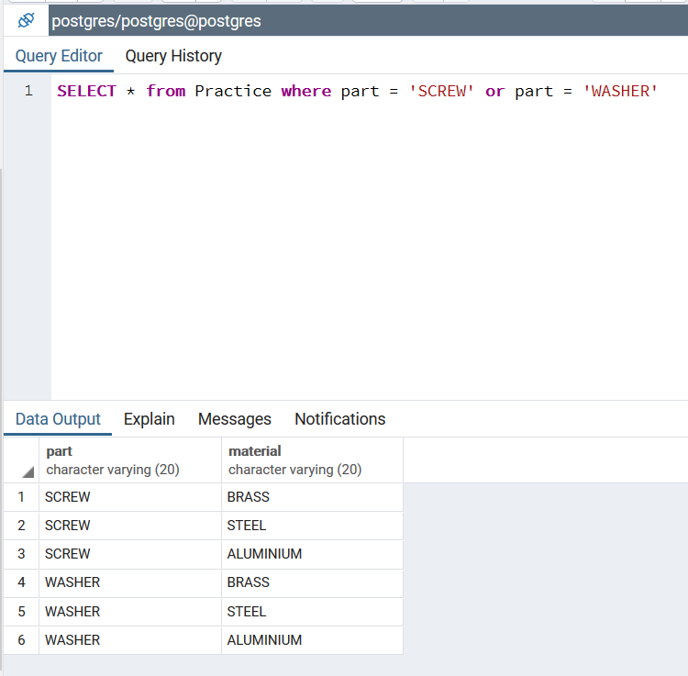

How many rows in the PRACTICE table have ‘*material’ = ‘*ALUMINIUM’

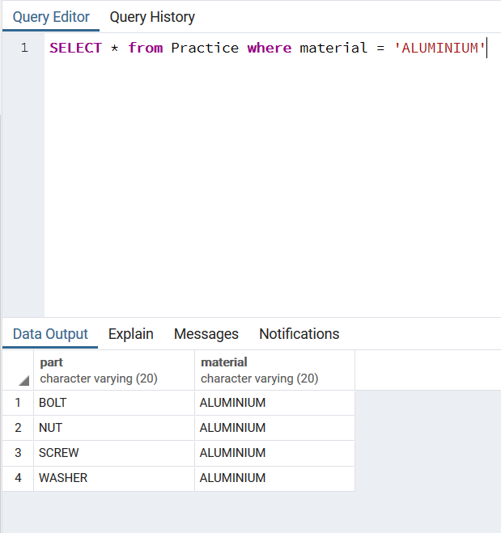

How many rows in the PRACTICE table do not have ‘*material’ = ‘*ALUMINIUM’

